

STUDENT CASE STUDY EXECUTION REPORT

Department | FED
Subject | DSA – 2
Academic Year | I-III Semester (2025 – 26)
Faculty Name | Ms. Mamatha
Student Name | Uppalapati Venkata Naga Varshitha
Roll Number | 2520030206
Branch | CSE
Course Outcome | CO 5 – Sorting and Searching Techniques for Data Prioritization

Case Study Title: Shipment Priority Ranking using Quick Sort in SmartLogix

Work Done Summary:
SmartLogix handles a large number of shipments every day, each with different delivery priorities, deadlines, and urgency levels. In order to ensure that important deliveries are processed first, shipment records must be arranged in priority order. Efficient sorting of
shipment data helps logistics managers make faster decisions and improve overall delivery performance.
In this case study, Quick Sort is used to sort shipment records based on priority values such as urgency score, delivery deadline, or shipment importance. Quick Sort is an efficient divide-and-conquer sorting algorithm that partitions data around a pivot and recursively sorts the
remaining elements.
Using Quick Sort in SmartLogix allows shipment records to be arranged quickly in ascending or descending order of priority. This helps the system rank urgent deliveries first, improves
dispatch planning, and supports faster decision-making in warehouse and logistics operations.
The case study demonstrates the importance of sorting algorithms in large-scale shipment data management.

Implementation Details:
- Store shipment records with attributes such as Shipment ID, priority level, and delivery deadline
- Use Quick Sort to sort shipment records based on shipment priority
- Select a pivot element and partition records into smaller and larger priority groups

- Recursively sort the left and right partitions
- Arrange shipment records in optimized order for dispatch
- Display sorted shipment priority list for logistics managers
- Improve shipment handling efficiency and delivery scheduling.

Result:
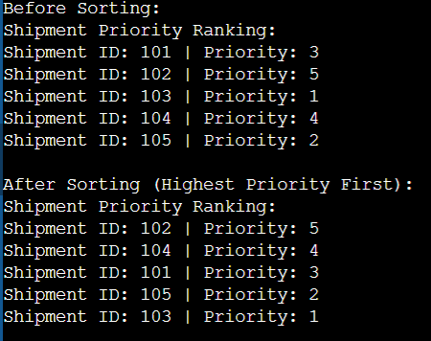
The Quick Sort algorithm successfully arranged shipment records according to their priority levels in SmartLogix. The sorted output enabled the system to identify urgent deliveries quickly and improved shipment dispatch planning. The implementation demonstrated that sorting algorithms are highly effective for shipment ranking, warehouse prioritization, and large-scale logistics data processing.
Time Complexity:
- Best Case: O (n log n)
- Average Case: O (n log n)
- Worst Case: O(n²)
- Partition Operation: O(n)

Github Link: https://github.com/srinivasvarshi7-beep/DSA-2-Casestudy.git

Student Signature: | Faculty Signature:

